# **Name: Abdurrahman Qureshi**

# **Roll No: 242466**

Practical No: 1

**Q) Create Various Patterns via for loops in Python**

CODE:

def my_function(x):

for i in range (x):

for j in range(i+1):

print("*",end=" ")

print("")

n = int(input("Enter a number:"))

my_function(n)

OUTPUT:

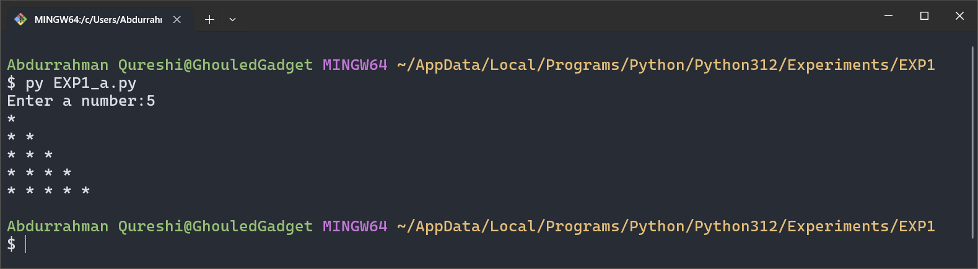

CODE:

def my_function(x):

for i in range (x):

for j in range(i):

print((j+1),end=" ")

print("")

n = int(input("Enter a number:"))

my_function(n)

OUTPUT:

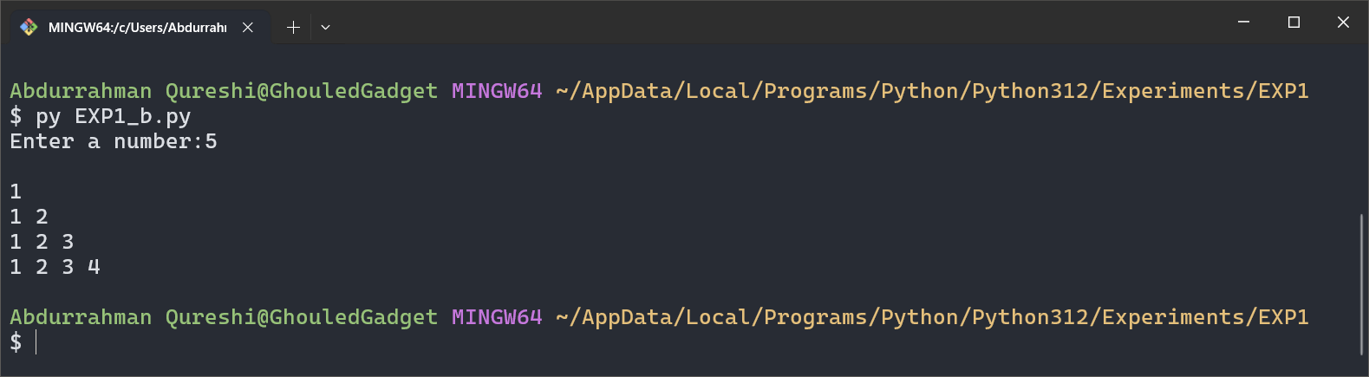

CODE:

def my_function(x):

k = 1

for i in range (x):

for j in range(i+1):

print(k,end=" ")

k = k+1

print("")

n = int(input("Enter a number:"))

my_function(n)

OUTPUT:

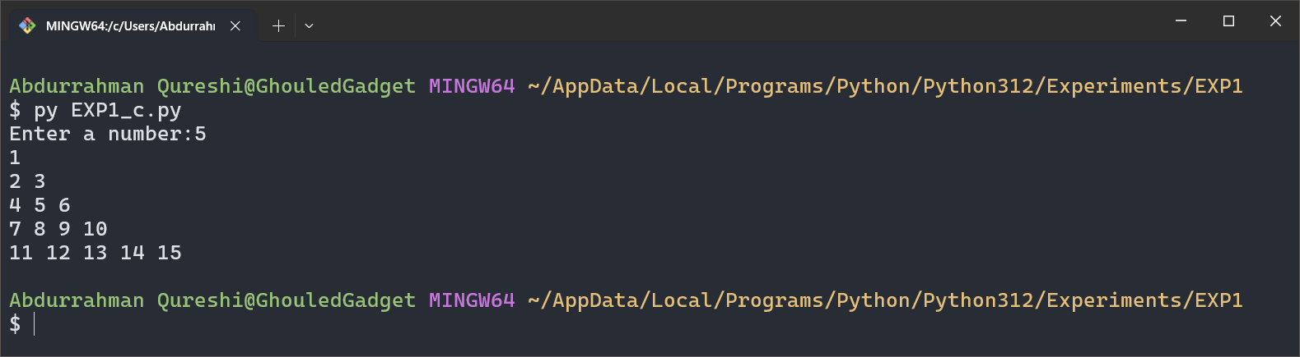

CODE:

def my_function(x):

k = 65

for i in range (x):

for j in range(i+1):

print(chr(k),end=" ")

k = k + 1

print("")

n = int(input("Enter a number:"))

my_function(n)

OUTPUT:

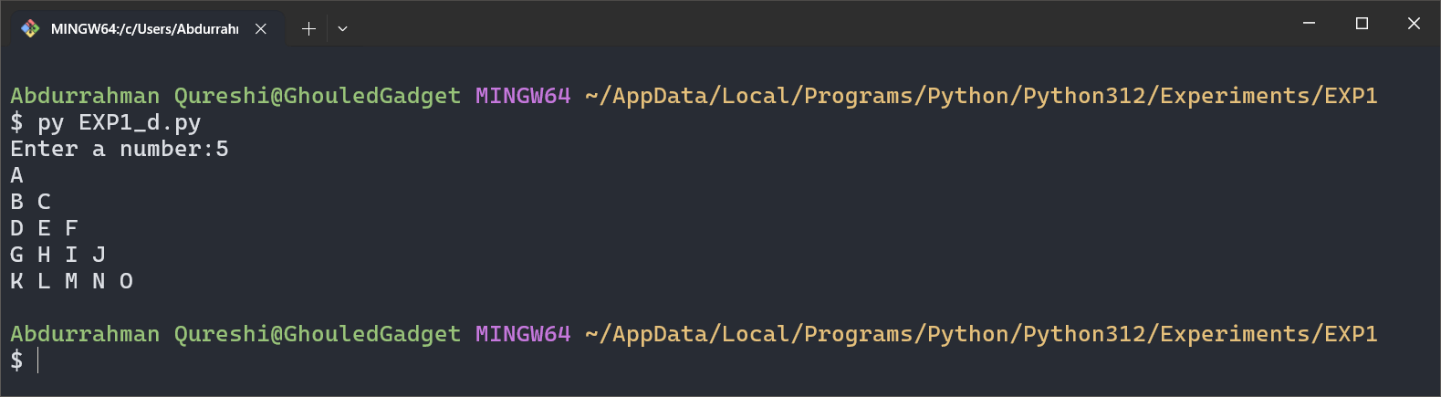

CODE:

def my_function(x):

for i in range (x):

k = 65

for j in range(i+1):

print(chr(k),end=" ")

k = k + 1

print("")

n = int(input("Enter a number:"))

my_function(n)

OUTPUT:

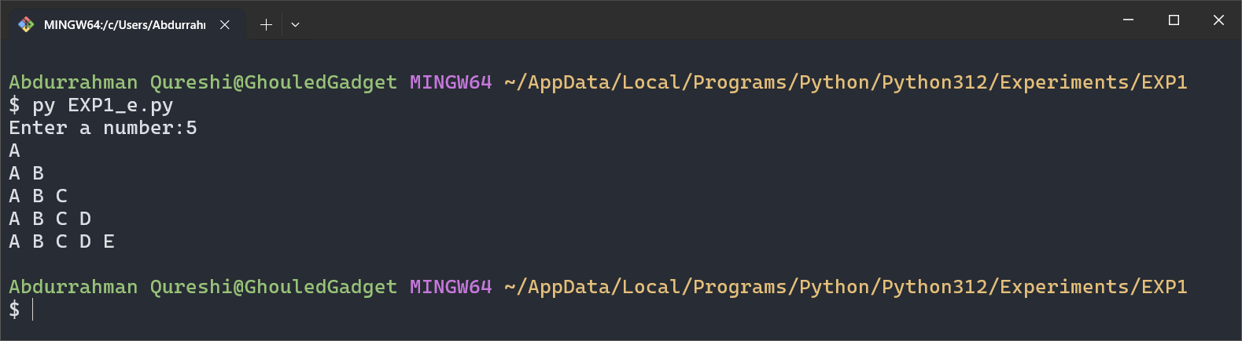

CODE:

def my_function(x):

for i in range (x):

for k in range (x, i, -1):

print(" ",end=" ")

for j in range(i+1):

print("*",end=" ")

print("")

n = int(input("Enter a number:"))

my_function(n)

OUTPUT:

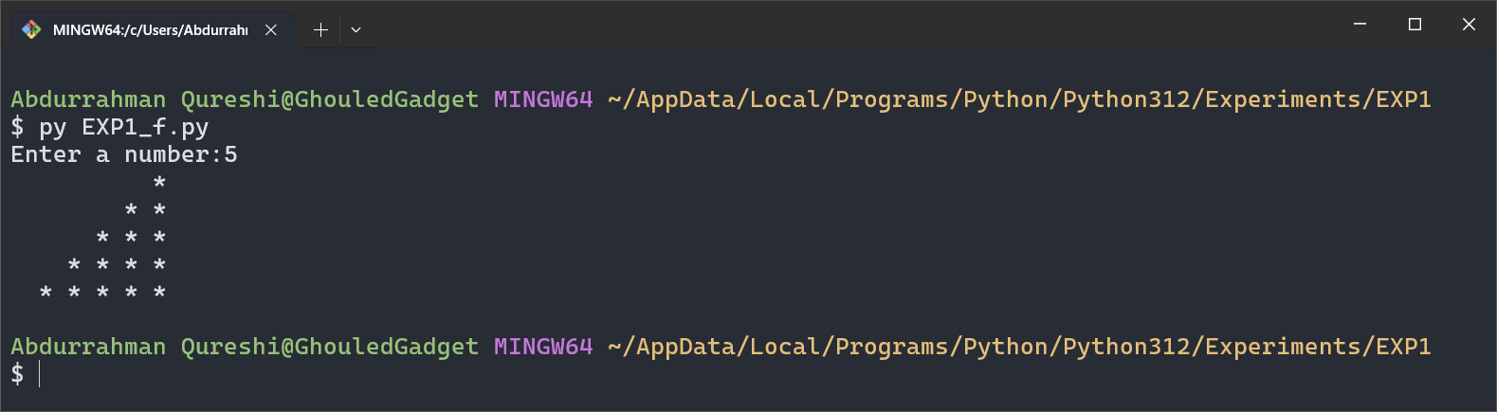

CODE:

def my_function(x):

for i in range (x):

for j in range(i):

print(j, end=" ")

print("")

n = int(input("Enter a number:"))

my_function(n)

OUTPUT:

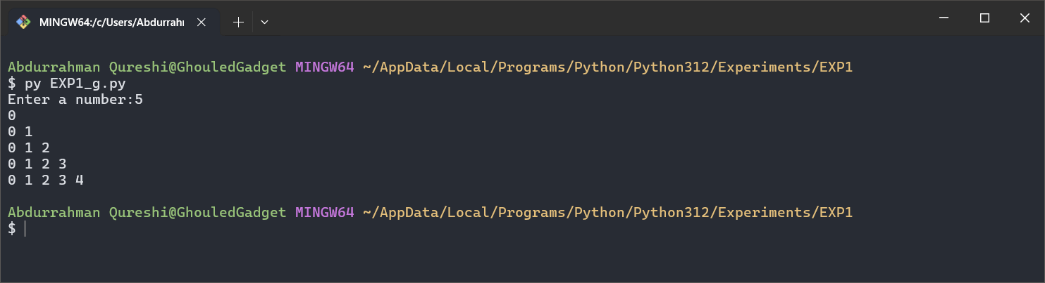

CODE:

def my_function(x):

for i in range (x,0,-1):

for j in range(1,i+1):

print(j, end=" ")

print("")

n = int(input("Enter a number:"))

my_function(n)

OUTPUT:

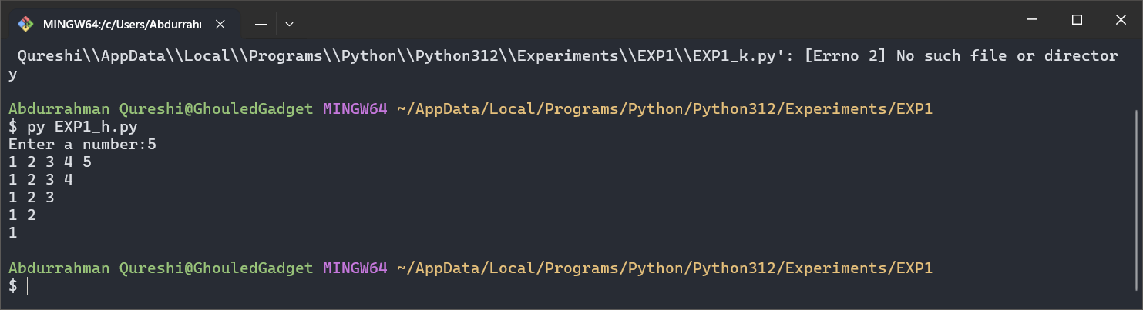

CODE:

def my_function(x):

for i in range(x):

for j in range(x,i+1,-1):

print(" ", end="")

for k in range(i+1):

print("*", end="")

for m in range(i):

print("*", end="")

for l in range(x,i+1,-1):

print(" ", end="")

print("")

n = int(input("Enter a number:"))

my_function(n)

OUTPUT:

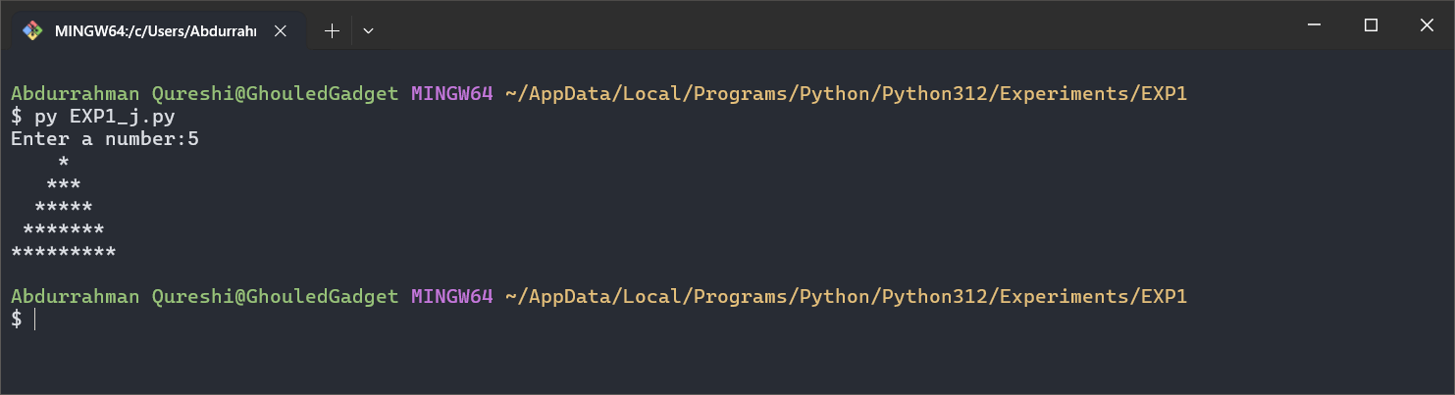

CODE:

def my_function():

for j in range(1,11):

print("====================")

print(" Table of: " , j)

print("====================")

print("")

for k in range(1,11):

res = j * k

print(k , " * " , j , " = " , res)

print("")

print("")

my_function()

OUTPUT:

